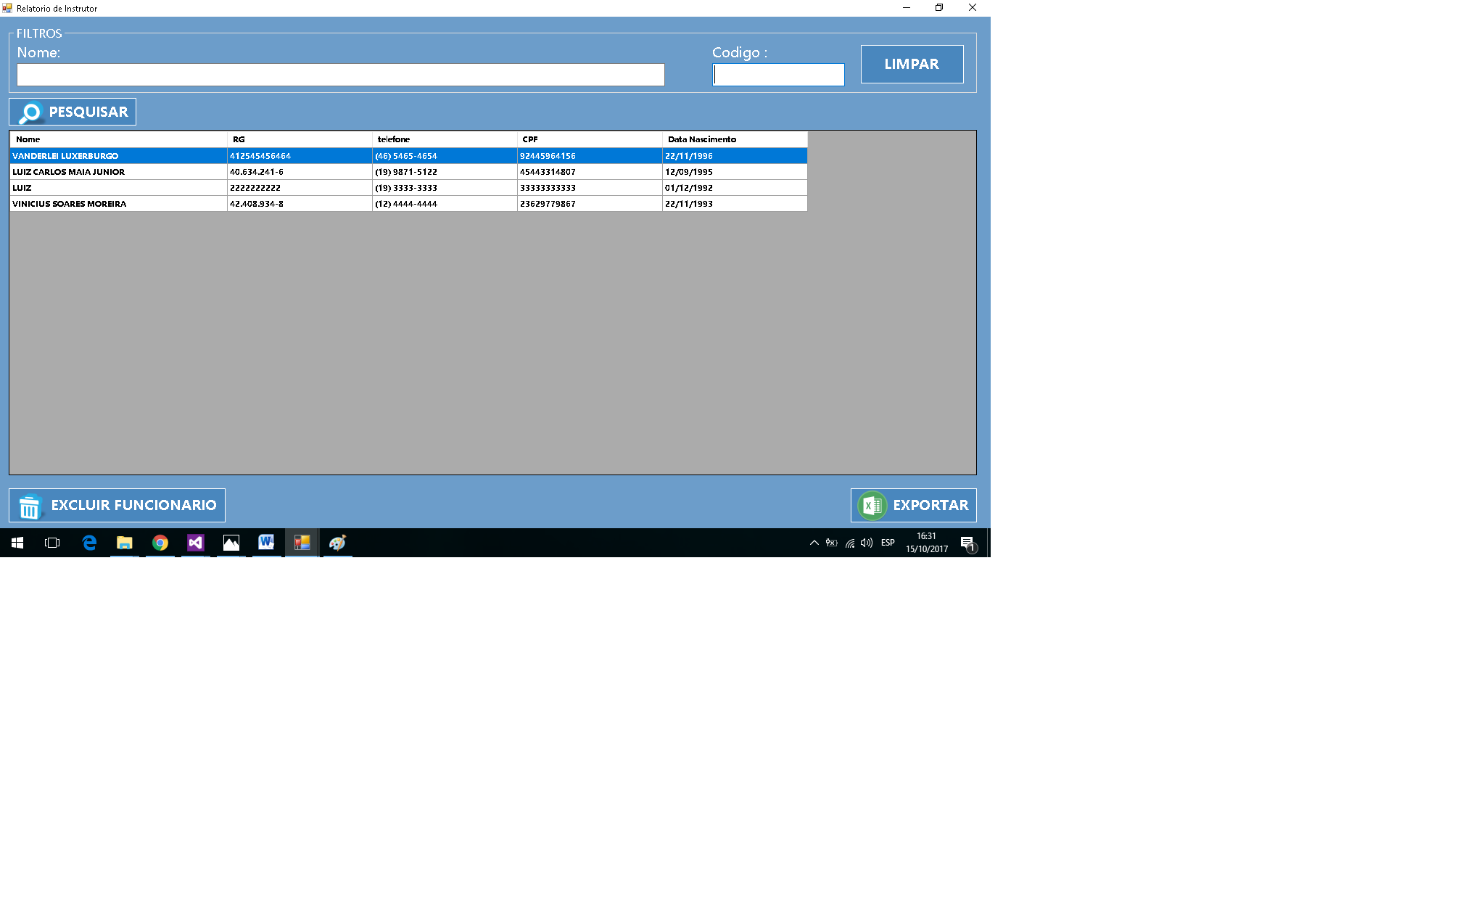

|  |  |  |  |  |
| --- | --- | --- | --- | --- |
| **CT NO.** | **PROPOSITO** | | | |
| **1** | **VERIFICAR SE IRA GERAR O RELATORIO** | | | |
| **PRÉ-CONDIÇÕES** | | | | |
| **Não tem** | | | | |
| **ENTRADA 1** | | **ENTRADA 2** | **ENTRADA 3** | **ENTRADA 4** |
| **NOME** | | **CODIGO** | **BOTAO PESQUISAR** | **EXCLUIR FUNCIONARIO** |
|  | |  |  |  |
|  | |  |  |  |
| **SAÍDAS ESPERADAS** | | | | |
| **RELATORIO GERADO** | | | | |

|  |  |  |  |  |
| --- | --- | --- | --- | --- |
| **TESTE No.** | **NOME** | **CODIGO** | **BOTAO** | **BOTAO**  **SAIDA ESPERADA** |
| **1** | **LUIZ** | **10** | **PESQUISAR** | **RELATORIO**  **GERADO** |

|  |  |  |  |  |
| --- | --- | --- | --- | --- |
| **TESTE No.** | **NOME** | **CODIGO** | **BOTAO** | **BOTAO**  **SAIDA ESPERADA** |
| **2** | **LUIZ** | **-** | **PESQUISAR** | **RELATORIO**  **GERADO** |

|  |  |  |  |  |
| --- | --- | --- | --- | --- |
| **TESTE No.** | **NOME** | **CODIGO** | **BOTAO** | **BOTAO**  **SAIDA ESPERADA** |
| **3** | **-** | **-** | **PESQUISAR** | **MENSAGEM DE ERRO** |

|  |  |  |  |  |
| --- | --- | --- | --- | --- |
| **TESTE No.** | **NOME** | **CODIGO** | **BOTAO** | **SAIDA ESPERADA** |
| **4** | **VINICIUS SOARES MOREIRA** | **12** | **EXCLUIR** | **INSTRUTOR EXCLUIDO** |

|  |  |  |  |  |  |  |
| --- | --- | --- | --- | --- | --- | --- |
| **Aplicado em** | **Aplicado**  **por** | **Quantidade**  **de falhas** | **Depurado por** | **Reaplicado**  **em** | **Reaplicado**  **por** | **Quantidade**  **de falhas** |
| **30/10/2017** | **Vinicius** | **1** | **Luiz** | **01/11/2017** | **Vinicius** | **0** |